CHAPTER 30

Magnetic Induction

1* · A uniform magnetic field of magnitude 2000 G is parallel to the x axis. A square coil of side 5 cm has a single turn and makes an angle θ with the z axis as shown in Figure 30-28. Find the magnetic flux through the coil when (a) θ = 0°, (b) θ = 30°, (c) θ = 60°, and (d) θ = 90°.
(a), (b), (c), (d) φ_{m} = BA cos θ | (a) φ_{m} = 2×10^{–1} × 25×10^{–4} Wb = 5×10^{–4} Wb = 0.5 mWb; (b) φ_{m} = 0.433 mWb; (c) φ_{m} = 0.25 mWb; (d) φ_{m} = 0

2 · A circular coil has 25 turns and a radius of 5 cm. It is at the equator, where the earth's magnetic field is 0.7 G north. Find the magnetic flux through the coil when its plane is (a) horizontal, (b) vertical with its axis pointing north, (c) vertical with its axis pointing east, and (d) vertical with its axis making an angle of 30° with north.
(a), (b), (c) Use Equ. 30-3 | (a) φ_{m} = [(25×7×10^{–5} ×π×25×10^{–4} ) cos 90°] Wb = 0  (b) φ_{m} = (1.37×10^{–5} cos 0°) Wb = 1.37×10^{–5} Wb  (c) φ_{m} = (1.37×10^{–5} cos 30°) Wb = 1.19×10^{–5} Wb

3 · A magnetic field of 1.2 T is perpendicular to a square coil of 14 turns. The length of each side of the coil is 5 cm. (a) Find the magnetic flux through the coil. (b) Find the magnetic flux through the coil if the magnetic field makes an angle of 60° with the normal to the plane of the coil.
(a), (b) Use Equ. 30-3 | (a) φ_{m} = (14×25×10^{–4} ×1.2) Wb = 0.042 Wb  (b) φ_{m} = (0.042 cos 60°) Wb = 0.021 Wb

4 · A circular coil of radius 3.0 cm has its plane perpendicular to a magnetic field of 400 G. (a) What is the magnetic flux through the coil if the coil has 75 turns? (b) How many turns must the coil have for the flux to be 0.015 Wb?
(a), (b) Use Equ. 30-3 | (a) φ_{m} = (75×π×9×10^{–4} ×4×10^{–2}) Wb = 8.48 mWb  (b) N = 75(15/8.48) = 133

5* · A uniform magnetic field B is perpendicular to the base of a hemisphere of radius R. Calculate the magnetic flux through the spherical surface of the hemisphere.
Note that φ_{m} through the base must also penetrate the spherical surface. Thus, φ_{m} = πR²B.

6 ·· Find the magnetic flux through a solenoid of length 25 cm, radius 1 cm, and 400 turns that carries a current of 3 A.
Use Equs. 29-9 and 30-3; φ_{m} = μ₀N ²AI/L | φ_{m} = 7.58×10^{–4} Wb

7 ·· Work Problem 6 for an 800-turn solenoid of length 30 cm, and radius 2 cm, carrying a current of 2 A.
Use Equs. 29-9 and 30-3; φ_{m} = μ₀N ²AI/L | φ_{m} = 6.74×10^{–3} Wb

8 ·· A circular coil of 15 turns of radius 4 cm is in a uniform magnetic field of 4000 G in the positive x direction. Find the flux through the coil when the unit vector perpendicular to the plane of the coil is (a) n = i, (b) n = j, (c) n = (i + j)/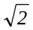, (d) n = k, and (e) n = 0.6i + 0.8j.
(a), (b), (c), (d), (e) Use Equ. 30-1 with B = 0.4 T i | (a) NA = 0.0704 m²; φ_{m} = 0.0302 Wb. (b) φ_{m} = 0  (c) 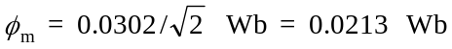. (d) φ_{m} = 0  (e) φ_{m} = 0.0169 Wb

9* ·· A solenoid has n turns per unit length, radius R₁, and carries a current I. (a) A large circular loop of radius R₂ > R₁ and N turns encircles the solenoid at a point far away from the ends of the solenoid. Find the magnetic flux through the loop. (b) A small circular loop of N turns and radius R₃ < R₁ is completely inside the solenoid, far from its ends, with its axis parallel to that of the solenoid. Find the magnetic flux through this small loop.
(a) B for R > R₁ = 0; so φ_{m} = NBA = μ₀nINπR₁².
(b) Now A = πR₃², so φ_{m} = μ₀nINπR₃².

10 ·· A long, straight wire carries a current I. A rectangular loop with two sides parallel to the straight wire has sides a and b with its near side a distance d from the straight wire, as shown in Figure 30-29. (a) Compute the magnetic flux through the rectangular loop. (Hint: Calculate the flux through a strip of area dA = b dx and integrate from x = d to x = d + a.) (b) Evaluate your answer for a = 5 cm, b = 10 cm, d = 2 cm, and I = 20 A.
(a) 1. Find dφ_{m}(x) = BdA; use Equ. 29-12  2. Integrate dφ_{m}(x) from d to (d + a)  (b) Evaluate φ_{m} | dφ_{m}(x) = (μ₀/2π)Ibdx/x  φ_{m} = (μ₀Ib/2π)ln[(d + a)/d]  φ_{m} = 4×10^{–7}×ln(7/2) Wb = 5.01×10^{–7} Wb

11 ··· A long, cylindrical conductor of radius R carries a current I that is uniformly distributed over its cross-sectional area. Find the magnetic flux per unit length through the area indicated in Figure 30-30.
At r < R, B = μ₀Ir/2πR ²(see Problem 29-49). The flux dφ_{m} through an area Ldr is BLdr, and the total flux through the area A is obtained by integrating dφ_{m} from r = 0 to r = R. One obtains φ_{m} = μ₀LI/4π, and the flux per unit length is then φ_{m} = μ₀I/4π.

12 ··· A rectangular coil in the plane of the page has dimensions a and b. A long wire that carries a current I is placed directly above the coil (Figure 30-31). (a) Obtain an expression for the magnetic flux through the coil as a function of x for 0 ≤ x ≤ 2b. (b) For what value of x is flux through the coil a maximum? For what value of x is the flux a minimum?
(a) Note that for 0 ≤ x ≤ b, B is symmetric about the wire, into the paper for the region below the wire and out of the paper for the region above the wire. Clearly, the net flux is zero for the area 2(b – x)a. We can now use the result of Problem 30-10 to find the flux through the remaining area of the rectangle. Thus, for 0 ≤ x ≤ b, we find φ_{m} = (μ₀Ia/2π)ln[x/(b – x)]. For x ≥ b, we find φ_{m} = (μ₀Ia/2π)ln[(x + b)/x).
(b) From the expressions derived in (a) we see that ⏐φ_{m}⏐ → ∞ as x → 0. This is the result of assuming a wire of infinitesimal radius; for R = 0, Equ. 29-12 diverges. The flux is a minimum (φ_{m} = 0) for x = b/2, as expected from symmetry.

13* · A conducting loop lies in the plane of this page and carries a clockwise induced current. Which of the following statements could be true?
(a) A constant magnetic field is directed into the page.
(b) A constant magnetic field is directed out of the page.
(c) An increasing magnetic field is directed into the page.
(d) A decreasing magnetic field is directed into the page.
(e) A decreasing magnetic field is directed out of the page.
(d)

14 · A uniform magnetic field B is established perpendicular to the plane of a loop of radius 5.0 cm, resistance 0.4 Ω, and negligible self-inductance. The magnitude of B is increasing at a rate of 40 mT/s. Find (a) the induced emf in the loop, (b) the induced current in the loop, and (c) the rate of Joule heating in the loop.
(a) Use Equs. 30-3 and 30-5; ⏐E⏐ = A dB/dt  (b) I = E/R  (c) P = I ²R | ⏐E⏐ = (0.04×π×25×10^{–4}) V = 0.314 mV  I = 0.785 mA  P = 0.247 μW

15 · The flux through a loop is given by φ_{m} = (t² – 4t)×10^{–1} Wb, where t is in seconds. (a) Find the induced emf E as a function of time. (b) Find both φ_{m} and E at t = 0, t = 2 s, t = 4 s, and t = 6 s.
(a) Use Equ. 30-5  (b) Evaluate E and φ_{m} for t = 0, 2, 4, and 6 s | E = –(0.2t – 0.4) V  E(0) = 0.4 V; E(2) = 0; E(4) = –0.4 V; E(6) = –0.8 V  φ_{m}(0) = 0; φ_{m}(2) = –0.4 Wb; φ_{m}(4) = 0; φ_{m}(6) = 1.2 Wb

16 · (a) For the flux given in Problem 15, sketch graphs of φ_{m} and E versus t. (b) At what time is the flux minimum? What is the emf at this time? (c) At what times is the flux zero? What is the emf at these times?
- The graphs of the flux, φ,and induced emf, E, are shown in the adjacent figure. The solid curve represents φ, the dashed curve represents E.  (b) The flux is a minimum at t = 2 s; at that instant E = 0.  (c) The flux is zero at t = 0 and t = 4 s; at these times,  E = 0.4 V and –0.4 V, respectively. | 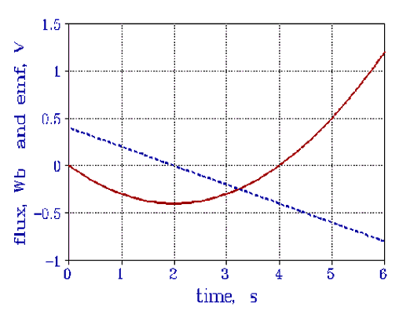

17* · The magnetic field in Problem 4 is steadily reduced to zero in 0.8 s. What is the magnitude of the emf induced in the coil of part (b)?

E = –dφ_{m}/dt
⏐E⏐ = 0.015/0.8 V = 18.75 mV

18 · A solenoid of length 25 cm and radius 0.8 cm with 400 turns is in an external magnetic field of 600 G that makes an angle of 50° with the axis of the solenoid. (a) Find the magnetic flux through the solenoid. (b) Find the magnitude of the emf induced in the solenoid if the external magnetic field is reduced to zero in 1.4 s.
(a) Use Equ. 30-3  (b) Use Equ. 30-5 | φ_{m} = (400×0.06×π×64×10^{–6} ×cos 50°) Wb = 3.10 mWb  E = (3.10×10^{–3}/1.4) V = 2.21 Mv

19 ·· A 100-turn circular coil has a diameter of 2.0 cm and resistance of 50 Ω. The plane of the coil is perpendicular to a uniform magnetic field of magnitude 1.0 T. The direction of the field is suddenly reversed. (a) Find the total charge that passes through the coil. If the reversal takes 0.1 s, find (b) the average current in the coil and (c) the average emf in the coil.
(a) 1. Use Equ. 30-5, E = IR, and I = ΔQ/Δt  2. Evaluate φ_{m} and ΔQ  (b) I_{av} = ΔQ/Δt  (c) E_{av} = I_{av} R | Δφ_{m} = –2φ_{m} = IRΔt = RΔQ; ΔQ = –2φ_{m} /R  φ_{m} = 31.4 mWb; ΔQ = –1.26 mC  I_{av} = 12.6 mA  E_{av} = 628 mV

20 ·· At the equator, a 1000-turn coil with a cross-sectional area of 300 cm² and a resistance of 15.0 Ω is aligned with its plane perpendicular to the earth's magnetic field of 0.7 G. If the coil is flipped over, how much charge flows through it?
ΔQ = –2φ_{m} /R (see Problem 30–19); ΔQ = 2NBA/R | ΔQ = 0.28 mC

21* ·· A circular coil of 300 turns and radius 5.0 cm is connected to a current integrator. The total resistance of the circuit is 20 Ω. The plane of the coil is originally aligned perpendicular to the earth's magnetic field at some point. When the coil is rotated through 90°, the charge that passes through the current integrator is measured to be 9.4 μC. Calculate the magnitude of the earth's magnetic field at that point.
1. Relate the flux change to the charge  2. Δφ_{m} = NBA; B = QR/NA= QR/Nπr² | E = –Δφ_{m}/Δt; I = E/R; Q = IΔt = –Δφ_{m}/R  B = 79.8 μT

22 ·· An elastic circular conducting loop is expanding at a constant rate so that its radius is given by R = R₀ + vt. The loop is in a region of constant magnetic field perpendicular to the loop. What is the emf generated in the expanding loop? Neglect possible effects of self-inductance.
The flux is given by φ_{m} = πR ²B = π(R₀ + vt)²B. Thus E = –(dφ_{m} /dt) = –2πvB(R₀ + vt).

23 ·· The wire in Problem 12 is placed at x = b/4. (a) Obtain an expression for the emf induced in the coil if the current varies with time according to I = 2t. (b) If a = 1.5 m and b = 2.5 m, what should be the resistance of the coil so that the induced current is 0.1 A? What is the direction of this current?
(a) From Problem 30-12, φ_{m} = (μ₀Ia/2π)ln(1/3) = –1.10μ₀Ia/2π. Thus E = 1.10μ₀a/π.
(b) R = E/I = 1.10μ₀a/πI; solve for R | R = 6.6 μΩ; the current is counterclockwise.

24 ·· Repeat Problem 23 if the wire is placed at x = b/3.
(a) For x = b/3, ln[x/(x – b)] = ln(1/2) = –0.693. Then E = 0.693μ₀a/π.
(b) Now R = [6.6(0.693/1.10)] μΩ = 4.16 μΩ; the current is again counterclockwise.

25* · Give the direction of the induced current in the circuit on the right in Figure 30-32 when the resistance in the circuit on the left is suddenly (a) increased and (b) decreased.
Note that when R is constant, B in the loop to the right points out of the paper.
(a) If R increases, I decreases and so does B. By Lenz’s law, the induced current is counterclockwise.
(b) Conversely, if R decreases, the induced current is clockwise.

26 ·· The two circular loops in Figure 30-33 have their planes parallel to each other. As viewed from A toward B, there is a counterclockwise current in loop A. Give the direction of the current in loop B and state whether the loops attract or repel each other if the current in loop A is (a) increasing and (b) decreasing.
(a) Current in B is clockwise; loops repel one another.
(b) Current in B is counterclockwise; loops attract one another.

27 ·· A bar magnet moves with constant velocity along the axis of a loop as shown in Figure 30-34. (a) Make a qualitative graph of the flux φ_{m} through the loop as a function of time. Indicate the time t₁ when the magnet is halfway through the loop. (b) Sketch a graph of the current I in the loop versus time, choosing I to be positive when it is counterclockwise as viewed from the left.
(a), (b) The adjacent figure shows the flux and induced current as a function of time as the bar magnet passes through the coil. When the center of the magnet passes through the plane of the coil dφ_{m} /dt = 0, and the current is zero. In the figure, the solid curve represents the flux, and the dashed curve represents the current. | 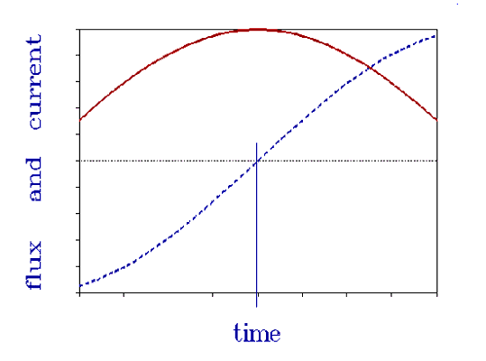

28 ·· A bar magnet is mounted on the end of a coiled spring in such a way that it moves with simple harmonic motion along the axis of a loop as shown in Figure 30-35. (a) Make a qualitative graph of the flux φ_{m} through the loop as a function of time. Indicate the time t₁ when the magnet is halfway through the loop. (b) Sketch the current I in the loop versus time, choosing I to be positive when it is counterclockwise as viewed from above.
(a), (b) The adjacent figure shows the flux, φ_{m} , and the induced current in the loop as a function of time. The flux is shown as the solid curve, the current as the dashed curve. The times when the magnet is halfway through the loop is indicated. At those times the flux is a maximum and the current is zero. | 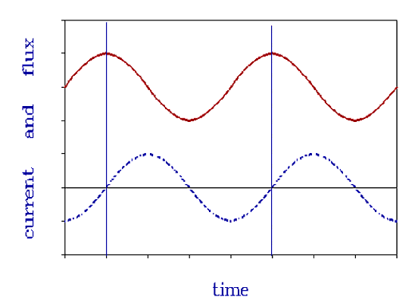

29* · A rod 30 cm long moves at 8 m/s in a plane perpendicular to a magnetic field of 500 G. The velocity of the rod is perpendicular to its length. Find (a) the magnetic force on an electron in the rod, (b) the electrostatic field E in the rod, and (c) the potential difference V between the ends of the rod.

(a) F = qv×B
(b) E = v×B
(c) V = E
F = 1.6×10^{–19} ×8×5×10^{–2} N = 6.4×10^{–20} N
E = 0.4 V/m
V = 0.12 V

30 · Find the speed of the rod in Problem 29 if the potential difference between the ends is 6 V.
V ∝ v; use the result of Problem 29 | v = (6/0.12)(8 m/s) = 400 m/s

31 · In Figure 30-14, let B be 0.8 T, v = 10.0 m/s, = 20 cm, and R = 2 Ω. Find (a) the induced emf in the circuit, (b) the current in the circuit, and (c) the force needed to move the rod with constant velocity assuming negligible friction. Find (d) the power input by the force found in part (c), and (e) the rate of Joule heat production I ²R.
(a) Use Equ. 30-6  (b) I = E/R; use Lenz’s law  (c) Use Equ. 28-5; F = BI  (d) P = Fv  (e) P = I ²R | E = (0.8×0.2×10.0) V = 1.6 V  I = 0.8 A, counterclockwise  F = 0.128 N  P = 1.28 W  P = 1.28 W

32 · Work Problem 31 for B = 1.5 T, v = 6 m/s, = 40 cm, and R = 1.2 Ω.
Repeating the procedure of the previous problem one obtains:
(a) E = 3.6 V (b) I = 3.0 A (c) F = 1.8 N (d) P = 10.8 W (e) P = 10.8 W

33* ·· A 10-cm by 5-cm rectangular loop with resistance 2.5 Ω is pulled through a region of uniform magnetic field B = 1.7 T (Figure 30-36) with constant speed v = 2.4 cm/s. The front of the loop enters the region of the magnetic field at time t = 0. (a) Find and graph the flux through the loop as a function of time. (b) Find and graph the induced emf and the current in the loop as functions of time. Neglect any self-inductance of the loop and extend your graphs from t = 0 to t = 16 s.
(a) For 0 < t < 4.17 s, φ_{m} = 0.05Bvt = 2.04×10^{–3}t;  for 4.17 s < t < 8.33 s, φ_{m} = 8.51 mWb;  for 8.33 s < t < 12.5 s, φ_{m} = 8.51×10^{–3}(t – 8.33);  for t > 12.5 s, φ_{m} = 0  The graph of φ_{m}(t) is shown on the right. Here φ_{m} is in mWb, t in s. | 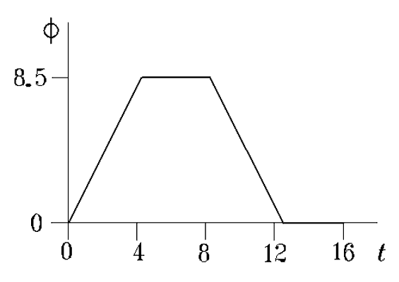

(b) E = –(dφ_{m}/dt); for 0 < t < 4.17 s, E = –2.04 mV  for 4.17 s < t < 8.33 s, E = 0;  for 8.33 s < t < 12.5 s, E = 2.04 mV;  for t > 12.5 s, E = 0.  The graph of E(t) is shown on the right. Here E is in mV and t in s.  The graph of the current is identical to that of E with the ordinate scale changed to I_{max} = 0.8 mA. | 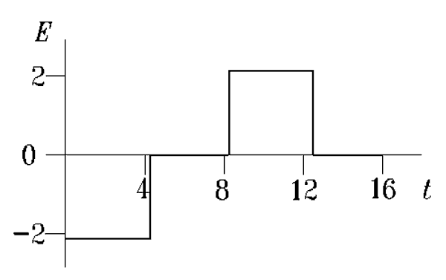

34 ·· A uniform magnetic field of magnitude 1.2 T is in the z direction. A conducting rod of length 15 cm lies parallel to the y axis and oscillates in the x direction with displacement given by x = (2 cm) cos 120πt. What is the emf induced in the rod?

Use Equ. 30-6 and v = dx/dt; E = –BAω sin(ωt)
E = –[1.36 sin (120πt)] V

35 ·· In Figure 30-37, the rod has a resistance R and the rails are horizontal and have negligible resistance. A battery of emf E and negligible internal resistance is connected between points a and b such that the current in the rod is downward. The rod is placed at rest at t = 0. (a) Find the force on the rod as a function of the speed v and write Newton's second law for the rod when it has speed v. (b) Show that the rod moves at a terminal speed and find an expression for it. (c) What is the current when the rod will approach its terminal speed?
(a) The net emf that drives a current in this circuit is the emf of the battery minus the induced emf in the rod as a result of its motion. Thus, I = (E – Bv)/R. The force on the rod due to this current is F = BI. Newton’s equation of motion is therefore ma = (B/R)(E – Bv).
(b) Note that a diminishes as v increases and becomes zero when v = v_{t} = E/B, where v_{t} is the terminal speed.
(c) It follows from the expression for I given above that when v = v_{t}, I = 0.

36 ·· In Example 30-8, find the total energy dissipated in the resistance and show that it is equal to mv₀².
The power dissipated is P = I ²R = (Bv)²/R, where v = v₀exp(-B²²t/mR). The total energy dissipated as the rod comes to rest is obtained by integrating dE = P dt. Thus,
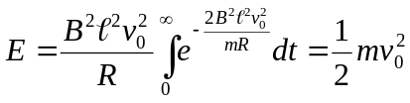
37* ·· Find the total distance traveled by the rod in Example 30-8.
Note that v = dx/dt = v₀e^{–Ct}, where C = B²²/mR. Integrating the differential equation gives x = 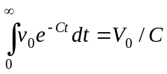.
The distance traveled is v₀mR/B²².

38 ·· In Figure 30-37, the rod has a resistance R and the rails have negligible resistance. A capacitor with charge Q₀ and capacitance C is connected between points a and b such that the current in the rod is downward. The rod is placed at rest at t = 0. (a) Write the equation of motion for the rod on the rails. (b) Show that the terminal speed of the rod down the rails is related to the final charge on the capacitor.
(a) In this case, the current is given by I = (Q/C – Bv)/R. The current is due to the discharge of the capacitor; consequently, I = –dQ/dt. The acceleration is also proportional to the current through F = BI = ma = m dv/dt. So dQ/dt = –(m/B) dv/dt, or dQ = –(m/B) dv. This is readily integrated; with Q = Q₀ for v = 0 one obtains
Q = Q₀ – mv/B. Thus the equation of motion is
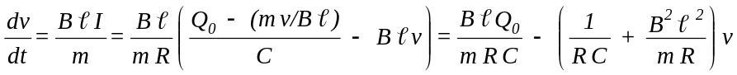
(b) At the terminal speed, F = 0 and therefore I = 0. Thus, Q_{f} /C = B v_{t}, or v_{t} = Q_{f} /CB.

39 ·· In Figure 30-38, a conducting rod of mass m and negligible resistance is free to slide without friction along two parallel rails of negligible resistance separated by a distance and connected by a resistance R. The rails are attached to a long inclined plane that makes an angle θ with the horizontal. There is a magnetic field B directed upward. (a) Show that there is a retarding force directed up the incline given by 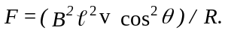 (b) Show that the terminal speed of the rod is 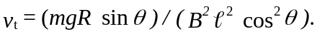
(a) Here, only the horizontal component of v produces an induced emf; from Equ. 30-6, E = Bv cos θ, and the current in the circuit is then I = (Bv/R) cos θ. The force due to the interaction of the current I with the magnetic field B is given by F = I×B, which points in the horizontal direction and has the magnitude F = (B²²v/R) cos θ. However, only the component of F along the inclined plane contributes to the retarding force. So F_{ret} = (B²²v/R) cos² θ.
(b) From Newton’s law, dv/dt = g sin θ – F_{ret} /m. At the terminal velocity, v_{t}, dv/dt = 0. Solving for v_{t} one finds
v_{t} = (mgR sin θ)/(B²² cos² θ).

40 ·· A simple pendulum has a wire of length supporting a metal ball of mass m. The wire has negligible mass and moves in a uniform horizontal magnetic field B. This pendulum executes simple harmonic motion having angular amplitude θ₀. What is the emf generated along the wire?
Since the pendulum moves with SHM, θ(t) = θ₀ cos ωt, where 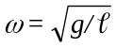. Consider a segment dr along the wire a distance r from the pivot. The emf dE induced in this segment due to the motion of the wire is given by
dE = Br(dθ/dt)dr = –Brωθ₀ sin ωt dr.Integrating from r = 0 to r = gives E = –1/2B²ωθ₀ sin ωt.

41* ·· A wire lies along the z axis and carries current I = 20 A in the positive z direction. A small conducting sphere of radius R = 2 cm is initially at rest on the y axis at a distance h = 45 m above the wire. The sphere is dropped at time t = 0. (a) What is the electric field at the center of the sphere at t = 3 s? Assume that the only magnetic field is that produced by the wire. (b) What is the voltage across the sphere at t = 3 s?
(a) 1. Find B(y); use Equ. 29-12  2. Find the velocity of the sphere at t = 3 s  3. Find y at t = 3 s; y = h – 1/2gt² and B  4. Find E = v×B  (b) V = 2RE | B = 20μ₀/2πy i = (4×10^{–6}/y) T i  v = –gt j = –29.4 m/s j  y = 0.855 m; B = 1.17×10^{–6} T i  E = 0.138 mV/m k  V = 5.50 μV

42 ·· In Figure 30-38, let θ = 30°, m = 0.4 kg, = 15 m, and R = 2.0 Ω. The rod starts from rest at the top of the inclined plane at t = 0. The rails have negligible resistance. There is a constant, vertically directed magnetic field of magnitude B = 1.2 T. (a) Find the emf induced in the rod as a function of its velocity down the rails. (b) Write Newton's law of motion for the rod; show that the rod will approach a terminal speed and determine its value.
(a) E = Bv cos θ (see Problem 30-39)  (b) dv/dt = g sin θ – (B²²v/Rm)cos² θ | E = (1.56v) V  Dv/dt = 4.905 – 3.038v; v_{t} = 1.61 m/s

43 ·· When the rod of Problem 42 moves at its terminal speed, what is the power dissipated in the resistor? What is the rate of change of the potential energy of the rod?
P = I²R; I = (Bv_{t} /R) cos θ (see Problem 30-39)  U = mgy; dU/dt = –mgv_{t} sin θ | P = 3.16 W  dU/dt = –3.16 W

44 ··· A solid conducting cylinder of radius 0.1 m and mass of 4 kg rests on horizontal conducting rails (Figure 30-39). The rails, separated by a distance a = 0.4 m, have a rough surface so the cylinder rolls rather than slides. A 12-V battery is connected to the rails as shown. The only significant resistance in the circuit is the contact resistance of 6 Ω between the cylinder and rails. The system is in a uniform vertical magnetic field. The cylinder is initially at rest next to the battery. (a) What must be the magnitude and direction of B so that the cylinder has an initial acceleration of 0.1 m/s² to the right? (b) Find the force on the cylinder as a function of its speed v. (c) Find the terminal velocity of the cylinder. (d) What is the kinetic energy of the cylinder when it has reached its terminal velocity? (Neglect the magnetic field due to the current in the battery–rails–cylinder loop and assume that the current density in the cylinder is uniform.)
Since the current through the rod is uniformly distributed, we may treat the current as though it were concentrated at the center of the rod.
(a) 1. Write the equations of motion. Let F_{f} be the friction force, and I_{m} the rod’s moment of inertia.  2. Solve for B with dv/dt = 0.1 m/s² and I = E/R  (b) 1. Write an expression for I  2. Write F_{net} in terms of the constants and v  3. Write the equation of motion  4. Try 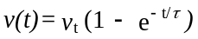0 with v_{t} = E/Ba  5. Substitute numerical values  (c) v_{t} = E/Ba  (d) K = 1/2mv_{t}² + 1/2I_{m}ω_{t}² = 3mv_{t}²/4 | F_{net} = BIa – F_{f} = m dv/dt = mr dω/dt; F_{f} r = I_{m} dω/dt;  r dω/dt = (BIa)/(m + I_{m}/r2) = 2BIa/3m = dv/dt  B = 0.75 T, pointing downward  I = (E – Bav)/R  F_{net} = (Ba/R)(E – Bav) – 1/2m dv/dt = m dv/dt  dv/dt = 2BaE/3mR – (2B²a²/3mR)v  Solution is correct with τ= 3mR/2B²a²  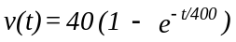 m/s  v_{t} = 40 m/s  K = 4800 J

45* ··· A rod of length is perpendicular to a long wire carrying current I, as shown in Figure 30-40. The near end of the rod is a distance d away from the wire. The rod moves with a speed v in the direction of the current I. (a) Show that the potential difference between the ends of the rod is given by
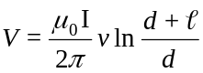
(b) Use Faraday's law to obtain this result by considering the flux through a rectangular area A = vt swept out by the rod.
(a) Consider a small segment of the rod of length dx. The induced field is dE = B(x)v dx, where B(x) = μ₀I/2πx.
Thus, 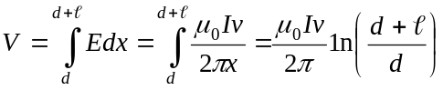.
(b) Again, consider a segment dx. dφ_{m} = B dA = B vt dx = (μ₀Iv/2πx)t dx. Except for the factor t, the integrand is the same as before; hence
φ_{m} = 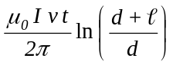. The induced emf is E = dφ_{m}/dt = 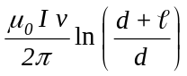.

46 ··· The loop in Problem 10 moves away from the wire with a constant speed v. At time t = 0, the left side of the loop is a distance d from the long straight wire. (a) Compute the emf in the loop by computing the motional emf in each segment of the loop that is parallel to the long wire. Explain why you can neglect the emf in the segments that are perpendicular to the wire. (b) Compute the emf in the loop by first computing the flux through the loop as a function of time and then using E = -dφ_{m}/dt and compare your answer with that obtained in part (a).
(a) The motion of the segments perpendicular to the long wire does not change the flux through the rectangular loop. Consequently, these segments do not contribute to the induced emf.
1. E = vBb (Equ. 30-6); B = 2×10^{–7}I/R (Equ. 29-12); note that the emf’s in both wires point up and  therefore oppose one another.  (b) 1. Generalize the result of Problem 30–10  2. E = –(dφ_{m} /dt) | For the near wire, E₁ = 2×10^{–7}Ibv/(d + vt); for the far wire, E₂ = 2×10^{–7}Ibv/(d + a + vt). So the total emf is  E = 2×10^{–7}Ibv[1/(d + vt) – 1/(d + a + vt)]  φ_{m} = (2×10^{–7}Ib) ln[(d + a + vt)/(d + vt)]  E = 2×10^{–7}Ibv[1/(d + vt) – 1/(d + a + vt)]

47 ··· A conducting rod of length rotates at constant angular velocity about one end, in a plane perpendicular to a uniform magnetic field B (Figure 30-41). (a) Show that the magnetic force on a charge q at a distance r from the pivot is Bqrω. (b) Show that the potential difference between the ends of the rod is 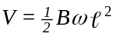. (c) Draw any radial line in the plane from which to measure θ = ωt. Show that the area of the pie-shaped region between the reference line and the rod is A = ²θ. Compute the flux through this area, and show that E = Bω² follows when Faraday's law is applied to this area.
(a) We have F = qv×B. Here v and B are at right angles, and v = rω. So F = qBrω.
(b) We can use Equ. 30-6 to find dE = Brω dr. Integrating from r = 0 to r = one obtains E = 1/2Bω².
(c) For any value of θ, the area dA between r and r + dr is rθ dr. Integrating from r = 0 to r = , one finds
A = 1/2²θ. The flux through this area is φ_{m} = BA = 1/2B²θ, and ⏐E⏐ = dφ_{m} /dt = 1/2B²ω.

48 · How would the self-inductance of a solenoid be changed if (a) the same length of wire were wound onto a cylinder of the same diameter but twice the length; (b) twice as much wire were wound onto the same cylinder; and (c) the same length of wire were wound onto a cylinder of the same length but twice the diameter?
(a) L is given by Equ. 30-9. Since the diameter does not change, the number of turns and the area A remain constant. However, n² is diminished by a factor of 4 and is increased by a factor of 2. Thus L is reduced by a factor of 2.
(b) Using twice as much wire and making no other change, n² and L are increased by a factor of 4.
(c) With twice the diameter, n² is reduced by a factor of 4, but A is increased by the same factor; L is unchanged.

49* · A coil with a self-inductance of 8.0 H carries a current of 3 A that is changing at a rate of 200 A/s. Find (a) the magnetic flux through the coil and (b) the induced emf in the coil.
(a) φ_{m} = LI; I = (3 + 200t) A  (b) E = -L(dI/dt) | φ_{m} = 24 + 1600t Wb  E = –1600 V

50 · A coil with self-inductance L carries a current I, given by I = I₀ sin 2πft. Find and graph the flux φ_{m} and the self-induced emf as functions of time.
By definition, φ_{m} = LI = LI₀ sin 2πf₀t and the induced emf E = –L dI/dt = –2πfLI₀ cos 2πft. The two quantities are shown in the figures. The maximum value of the flux is LI₀; the maximum value of the induced emf is 2πfLI₀. | 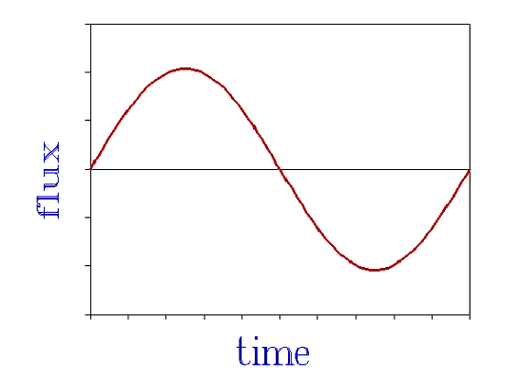  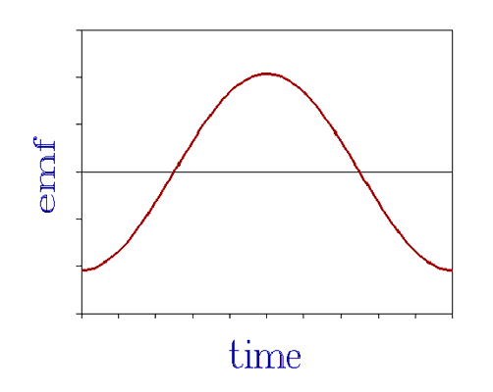

51 ·· A solenoid has a length of 25 cm, a radius of 1 cm, and 400 turns, and carries a 3-A current. Find (a) B on the axis at the center of the solenoid; (b) the flux through the solenoid, assuming B to be uniform; (c) the self-inductance of the solenoid; and (d) the induced emf in the solenoid when the current changes at 150 A/s.

(a) Use Equ. 29-9
(b) φ_{m} = NBA (Equ. 30-3)
(c) L = φ_{m} /I (Equ. 30-7)
(d) Use Equ. 30-10
B = (4π×10^{–7} ×1600×3) T = 6.03 mT
φ_{m} = 7.58×10^{–4} Wb
L = 0.253 mH
⏐E⏐ = 37.9 mV

52 ·· Two solenoids of radii 2 cm and 5 cm are coaxial. They are each 25 cm long and have 300 and 1000 turns, respectively. Find their mutual inductance.
Use Equ. 30-13 | n₁ = 4000 m^{–1}, n₂ = 1200 m^{–1}; M = 1.89 mH

53* ·· A long, insulated wire with a resistance of 18 Ω/m is to be used to construct a resistor. First, the wire is bent in half, and then the doubled wire is wound in a cylindrical form as shown in Figure 30-42. The diameter of the cylindrical form is 2 cm, its length is 25 cm, and the total length of wire is 9 m. Find the resistance and inductance of this wire-wound resistor.
Note that the current in the two parts of the wire is in opposite directions. Consequently, the total flux in the coil is zero, and the self inductance is also zero. L = 0. The length of the wire is 9 m, so its resistance is 9×18 Ω = 162 Ω.

54 ·· Figure 30-43 shows two long solenoids each with 2000 turns of wire. The outer solenoid is 20 cm long and has a diameter of 2 cm. The inner solenoid is 10 cm long and has a diameter of 1 cm. Find the effective inductance of this arrangement.
1. Write the expression for L (see Problem 99)  2. Evaluate L₁ and L₂ using Equs. 30-9  3. Evaluate M = μ₀N₁N₂A₁/₁  4. Evaluate L = L₁ + L₂ – 2M; note that flux of L₁ opposes that of L₂; use the negative sign. | L = L₁ + L₂ ± 2M  L₁ = μ₀ ×π×10³ H; L₂ = μ₀ ×2π×10³ H  M = μ₀ ×π×10³ H  L = 2π×10³ μ₀ H = 7.90 mH

55 ··· In Figure 30-44, circuit 2 has a total resistance of 300 Ω. A total charge of 2×10^{–4} C flows through the galvanometer in circuit 2 when switch S in circuit 1 is closed. After a long time, the current in circuit 1 is 5 A. What is the mutual inductance between the two coils?
1. Use Kirchhoff’s law for the galvanometer circuit  2. Integrate each term from t = 0 to t = ∞  3. Solve for and evaluate M | M dI₁/dt + L₂ dI₂/dt – RI₂ = 0  MI_{1∞} + L₂I_{2∞} – RQ = 0; I_{2∞} = 0  M = RQ/I_{2∞} = 12 mH

56 ··· Show that the inductance of a toroid of rectangular cross section as shown in Figure 30-45 is given by
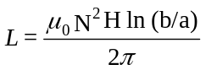
where N is the total number of turns, a is the inside radius, b is the outside radius, and H is the height of the toroid. From Equ. 29-17, B = μ₀NI/2πr. Consider a strip of height H and width dr; the flux in this strip is
dφ_{m} = BHdr. Integrate dφ_{m} from r = a to r = b. The result is φ_{m} = (μ₀NIH/2π) ln(b/a). This flux encloses N turns, so L = Nφ_{m} /I = (μ₀N ²H/2π) ln(b/a).

57* · If the current through an inductor were doubled, the energy stored in the inductor would be (a) the same. (b) doubled. (c) quadrupled. (d) halved. (e) quartered.
(c)

58 · A coil with a self-inductance of 2.0 H and a resistance of 12.0 Ω is connected across a 24-V battery of negligible internal resistance. (a) What is the final current? (b) How much energy is stored in the inductor when the final current is attained?
(a) I_{f} = E/R  (b) Use Equ. 30-16 | I_{f} = 2 A  U_{m} = 4 J

59 · Find (a) the magnetic energy, (b) the electric energy, and (c) the total energy in a volume of 1.0 m³ in which there is an electric field of 10⁴ V/m and a magnetic field of 5000 G.
(a) u_{E} = 1/2ε₀E ² (Equ. 25-11)  (b) u_{m} = 1/2B²/μ₀  (c) U = U_{E} + U_{m} ≈ U_{m} | U_{E} = 4.43×10^{–4} J  U_{m} = 9.95×10⁴ J  U = 9.95×10⁴ J

60 ·· In a plane electromagnetic wave such as a light wave, the magnitudes of the electric and magnetic fields are related by E = cB, where c = 1/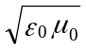 is the speed of light. Show that in this case the electric and the magnetic energy densities are equal.
From Equs. 25-11 and 30-17 we have u_{E} = 1/2ε₀E ² and u_{m} = 1/2B ²/μ₀. If E = cB, then E ² = B ²/ε₀μ₀ and u_{E} = u_{m}.

61* ·· A solenoid of 2000 turns, area 4 cm², and length 30 cm carries a current of 4.0 A. (a) Calculate the magnetic energy stored in the solenoid from LI ². (b) Divide your answer in part (a) by the volume of the solenoid to find the magnetic energy per unit volume in the solenoid. (c) Find B in the solenoid. (d) Compute the magnetic energy density from u_{m} = B²/2μ₀, and compare your answer with your result for part (b).
(a) Use Equ. 30-9 to find L; U_{m} = 1/2LI ²  - u_{m} = U_{m}/V = U_{m}/A  - B = μ₀nI = μ₀NI/  (d) u_{m} = B²/2μ₀ | L = 6.70 mH; U_{m} = 53.6 mJ  u_{m} = 447 J/m³  B = 33.5 mT  u_{m} = 447 J/m³ as in part (b)

62 ·· A long, cylindrical wire of radius a = 2 cm carries current I = 80 A uniformly distributed over its cross-sectional area. Find the magnetic energy per unit length within the wire.
Consider a cylindrical annulus of thickness dr at a radius r < a. The field B is given by B = μ₀Ir/2πa² (see Problem 29-49). The magnetic energy per unit length in this annulus is dU_{m} = (μ₀I ²r²/8π²a⁴)2πr dr. To find the total magnetic energy within the cylinder, integrate dU_{m} from r = 0 to r = a. The result is U_{m} = μ₀I ²/16π. Note that the magnetic energy per unit length is independent of the radius of the cylinder and depends only on the total current. Substitute numerical values. U_{m} = 0.16 mJ/m.

63 ·· A toroid of mean radius 25 cm and circular cross section of radius 2 cm is wound with a superconducting wire of length 1000 m that carries a current of 400 A. (a) What is the number of turns on the coil? (b) What is the magnetic field at the mean radius? (c) Assuming that B is constant over the area of the coil, calculate the magnetic energy density and the total energy stored in the toroid.
(a) Length per turn = 2πr; N = L/2πr  (b) Use Equ. 29-17; here r = r_{mean}  (c) Use Equ. 30-17; V ≈ 2π²r²r_{mean}; U_{m} = Vu_{m} | N = 7958  B = 2.55 T  u_{m} = 2.58×10⁶ J/m³; U_{m} = 5.09 kJ

64 · A coil of resistance 8.0 Ω and self-inductance 4.0 H is suddenly connected across a constant potential difference of 100 V. Let t = 0 be the time of connection, at which the current is zero. Find the current I and its rate of change dI/dt at times (a) t = 0, (b) t = 0.1 s, (c) t = 0.5 s, and (d) t = 1.0 s.
(a), (b), (c), (d) Use Equs. 30-21 and 30-22  and evaluate for t = 0, 0.1 s, 0.5 s, and 1.0 s | I = 12.5(1 – e^{–t/0.5} ) A; dI/dt = 25e^{–t/0.5} A/s  t = 0: I = 0, dI/dt = 25 A/s  t = 0.1 s: I = 2.27 A, dI/dt = 20.5 A/s  t = 0.5 s: I = 7.90 A, dI/dt = 9.20 A/s  t = 1.0 s: I = 10.8 A, dI/dt = 3.38 A/s

65* · The current in a coil with a self-inductance of 1 mH is 2.0 A at t = 0, when the coil is shorted through a resistor. The total resistance of the coil plus the resistor is 10.0 Ω. Find the current after (a) 0.5 ms and (b) 10 ms.
(a), (b) I(t) = I₀ e^{–(R/L)t}; R/L = 10⁴ s^{–1} | (a) I(0.5 ms) = 13.5 mA (b) I(10 ms) = 7.44×10^{–44} A ≅ 0

66 ·· In the circuit of Figure 30-20, let E₀ = 12.0 V, R = 3.0 Ω, and L = 0.6 H. The switch is closed at time t = 0. At time t = 0.5 s, find (a) the rate at which the battery supplies power, (b) the rate of Joule heating, and (c) the rate at which energy is being stored in the inductor.
(a) 1. Use Equs. 30-21 and 30-22  2. Find I(0.5 s); P = IE  (b) P_{J} = I ²R  (c) dU_{L} /dt = LI dI/dt | I = 4(1 – e^{–5t} ) A; dI/dt = 20e^{–5t} A/s  I = 3.67 A; P = 44.1 W  P_{J} = 40.4 W  dI/dt = 1.64 A/s; dU_{L} /dt = 3.62 W = P – P_{J}

67 ·· Do Problem 66 for the times t = 1 s and t = 100 s.
Proceeding as in the preceding problem one obtains, for t = 1.0 s, I = 3.973 A and dI/dt = 0.135 A/s. Then:
(a) P = 47.7 W; (b) P_{J} = 47.4 W; (c) dU_{L} /dt = 0.322 W. For t = 100 s, I = 4.00 A and dI/dt ≈ 0. So,
(a) P = 48.0 W; (b) P_{J} = 48.0 W; (c) dU_{L} /dt = 0.

68 ·· The current in an RL circuit is zero at time t = 0 and increases to half its final value in 4.0 s. (a) What is the time constant of this circuit? (b) If the total resistance is 5 Ω, what is the self-inductance?
(a) Here e^{–t/τ}= 0.5; find τfor t = 4 s  (b) L/R = τ(Equ. 3-22) | 4/τ= ln 2; τ= 5.77 s  L = Rτ= 28.9 H

69* ·· How many time constants must elapse before the current in an RL circuit that is initially zero reaches (a) 90%, (b) 99%, and (c) 99.9% of its final value?
(a), (b), (c) 1 – e^{–t/τ}= x; t/τ= ln[1/(1 – x)] | (a) x = 0.9, t/τ= 2.30; (b) x = 0.99, t/τ= 4.61;  (c) x = 0.999, t/τ= 6.91

70 ·· A coil with inductance 4 mH and resistance 150 Ω is connected across a battery of emf 12 V and negligible internal resistance. (a) What is the initial rate of increase of the current? (b) What is the rate of increase when the current is half its final value? (c) What is the final current? (d) How long does it take for the current to reach 99% of its final value?
(a) From Equs. 30-21 and 30-22, dI/dt = E/L e^{–Rt/L}  (b) When I = I₀/2, e^{–Rt/L} = 0.5  (c) I_{f} = E/R  (d) Find t when e^{–Rt/L} = 0.01 | For t = 0, dI/dt = 3.0 kA/s  dI/dt = 1.5 kA/s  I_{f} = 80 mA  t = (L/R) ln 100 = 0.123 ms

71 ·· A large electromagnet has an inductance of 50 H and a resistance of 8.0 Ω. It is connected to a dc power source of 250 V. Find the time for the current to reach (a) 10 A and (b) 30 A.
(a) 1. Write I(t) using Equs. 30-21 and 30-22  2. Solve for t when (1 – e^{–0.16t} ) = 0.32  (b) Solve for t when (1 – e^{–0.16t} ) = 0.96 | I(t) = 31.25(1 – e^{–0.16t} ) A  t = [ln (1/0.68)]/0.16 = 2.41 s  t = 20.1 s

72 ·· Given the circuit shown in Figure 30-46, assume that switch S has been closed for a long time so that steady currents exist in the circuit and that the inductor L is made of superconducting wire so that its resistance may be considered to be zero. (a) Find the battery current, the current in the 100-Ω resistor, and the current through the inductor. (b) Find the initial voltage across the inductor when switch S is opened. (c) Give the current in the inductor as a function of time measured from the instant of opening switch S.
(a) The 100-Ω resistor is shorted by L  (b) V_{Li} = (100 Ω)(1 A)  (c) I_{L}(t) = I_{L}(0) e^{–Rt/L} | I = 1 A; I₁₀₀ = 0; I_{L} = 1 A  V_{Li} = 100 V  I_{L}(t) = e^{–50t} A

73* ·· Compute the initial slope dI/dt at t = 0 from Equation 30-24, and show that if the current decreased steadily at this rate, it would be zero after one time constant.
I = I₀ e^{–t/τ}; dI/dt = –(1/τ)I₀ e^{–t/τ}. At t = 0, dI/dt = –I₀/τ. If I is a linear function of t, then I = I₀(1 – t/τ) and
I = 0 at t = τ.

74 ·· An inductance L and resistance R are connected in series with a battery as in Figure 30-22. A long time after switch S₁ is closed, the current is 2.5 A. When the battery is switched out of the circuit by opening switch S₁ and closing S₂, the current drops to 1.5 A in 45 ms. (a) What is the time constant for this circuit? (b) If R = 0.4 Ω, what is L?
(a) I = I₀ e^{–t/τ}; solve for τ  (b) L = τR | e^{–0.045/τ}= 0.6; τ= 0.0881 s  L = 35.2 mH

75 ·· When the current in a certain coil is 5.0 A and is increasing at the rate of 10.0 A/s, the potential difference across the coil is 140 V. When the current is 5.0 A and is decreasing at the rate of 10 A/s, the potential difference is 60 V. Find the resistance and self-inductance of the coil.
1. V = IR + L dI/dt; write the two conditions given  2. Solve for R and L | 140 = 5R + 10L; 60 = 5R - 10L  R = 20 Ω, L = 4 H

76 ·· For the circuit of Figure 30-47, (a) find the rate of change of the current in each inductor and in the resistor just after the switch is closed. (b) What is the final current? (Use the result from Problem 92.)
(a) 1. Find L_{eff} and τ; see Problem 30-92  2. At t = 0, dI_{R}/dt = E/L  3. Note that at t = 0, IR = 0; L dI_{L} /dt = E  (b) I_{f} = E/R | L_{eff} = 2.67 mH  dI_{R}/dt = 9.0 kA/s  L = 8 mH, dI_{L} /dt = 3 kA/s; L = 4 mH, dI_{L} /dt = 6 kA/s  I_{f} = 1.6 A

77* ·· For the circuit of Example 30-11, find the time at which the power dissipation in the resistor equals the rate at which magnetic energy is stored in the inductor.
1. Find the rate of energy storage in L  2. Set I ²R = LI(dI/dt)  3. Solve for t/τand find t for τ= 333 μs | dU_{L} /dt = d(1/2LI ²)/dt = LI(dI/dt)  1/τ= (1/I)(dI/dt) = e^{–t/τ}/[τ(1 – e^{–t/τ})]  t/τ= ln(2); t = 231 μs

78 ··· In the circuit of Figure 30-21, let E₀ = 12.0 V, R = 3.0 Ω, and L = 0.6 H. The switch is closed at time t = 0. From time t = 0 to t = τ, find (a) the total energy that has been supplied by the battery, (b) the total energy that has been dissipated in the resistor, and (c) the energy that has been stored in the inductor. (Hint: Find the rates as functions of time and integrate from t = 0 to t = τ= L/R.)
- Integrate P = EI from 0 to τ; τ= L/R and I is  given by Equ. 30-21  (b) Integrate I²R from 0 to τwith I given by  Equ. 30-21  (c) At t = τ, U_{L} = 1/2LI ² = (E²L/R²)(1 – e^{–1})² | (E²/R)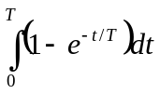 = E²τ/Re = E²L/R²e; E = 3.53 J  (E²/R)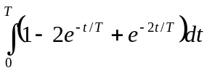 = (E²/R)(2τ/e –τ/2 – τ/2e²);  E_{J} = 0.168E²L/R² = 1.61 J  U_{L} = 1.92 J; note that U_{L} + E_{J} = E

79 · Two identical bar magnets are dropped from equal heights. Magnet A is dropped from above bare earth, whereas magnet B is dropped from above a metal plate. Which magnet strikes first? (a) Magnet A (b) Magnet B (c) Both strike at the same time. (d) Whichever has the N pole toward the ground. (e) Whichever has the S pole toward the ground.
(a)

80 · True or false:
(a) The induced emf in a circuit is proportional to the magnetic flux through the circuit.
(b) There can be an induced emf at an instant when the flux through the circuit is zero.
(c) Lenz's law is related to the conservation of energy.
(d) The inductance of a solenoid is proportional to the rate of change of the current in it.
(e) The magnetic energy density at some point in space is proportional to the square of the
magnetic field at that point.
(a) False (b) True (c) True (d) False (e) True

81* · A bar magnet is dropped inside a long vertical tube. If the tube is made of metal, the magnet quickly approaches a terminal speed, but if the tube is made of cardboard, it does not. Explain.
The time varying magnetic field of the magnet sets up eddy currents in the metal tube.The eddy currents establish a magnetic field with a magnetic moment opposite to that of the moving magnet; thus the magnet is slowed down. If the tube is made of a nonconducting material, there are no eddy currents.

82 · A circular coil of radius 3.0 cm has 6 turns. A magnetic field B = 5000 G is perpendicular to the coil. (a) Find the magnetic flux through the coil. (b) Find the magnetic flux through the coil if the coil makes an angle of 20° with the magnetic field.
(a), (b) Use Equ. 30-3; B = 0.5 T; A = 2.83×10^{–3} m² | (a) φ_{m} = 8.48 mWb; (b) φ_{m} = 7.97 mWb

83 · The magnetic field in Problem 82 is steadily reduced to zero in 1.2 s. Find the emf induced in the coil when (a) the magnetic field is perpendicular to the coil and (b) the magnetic field makes an angle of 20° with the normal to the coil.
(a), (b) Use Equ. 30-5; E = –Δφ/Δt = φ_{m} /Δt | (a) E = 7.07 mV; (b) E = 6.64 mV

84 · A 100-turn coil has a radius of 4.0 cm and a resistance of 25 Ω. At what rate must a perpendicular magnetic field change to produce a current of 4.0 A in the coil?
From Equ. 30-5, E = IR = NA(dB/dt) | dB/dt = IR/NA = 199 T/s

85* ·· Figure 30-48 shows an ac generator. It consists of a rectangular loop of dimensions a and b with N turns connected to slip rings. The loop rotates with an angular velocity ω in a uniform magnetic field B. (a) Show that the potential difference between the two slip rings is E = NBabω sin wt. (b) If a = 1.0 cm, b = 2.0 cm, N = 1000, and B = 2 T, at what angular frequency ω must the coil rotate to generate an emf whose maximum value is 110 V?
(a) Find φ_{m}(t) and E = –dφ_{m} /dt  (b) E_{max} for sin ωt = 1; solve for ω | φ_{m}(t) = NBA cos ωt; E = NBabω sin ωt  ω = 110/(1000×2×10^{–4}×2) = 275 rad/s

86 ·· Prior to about 1960, magnetic field strength was measured by means of a rotating coil gaussmeter. This device used a small loop of many turns rotating on an axis perpendicular to the magnetic field at fairly high speed and connected to an ac voltmeter by means of slip rings like those shown in Figure 30-48. The sensing coil for a rotating coil gaussmeter has 400 turns and an area of 1.4 cm². The coil rotates at 180 rpm. If the magnetic field strength is 0.45 T, find the maximum induced emf in the coil and the orientation of the coil relative to the field for which this maximum induced emf occurs.
Use the result of Problem 30-85 | E_{max} = (400×0.45×1.4×10^{–4}×18.85) V = 0.475 V when the plane of the coil is parallel to the magnetic field.

87 ·· Show that the effective inductance for two inductors L₁ and L₂ connected in series such that none of the flux from either passes through the other is given by L_{eff} = L₁ + L₂.
Since the inductors L₁ and L₂ are in series, I₁ = I₂ = I and dI₁/dt = dI₂/dt = dI/dt. The total induced emf is E = E₁ + E₂ = (L₁ + L₂) dI/dt = L_{eff} dI/dt. So L_{eff} = L₁ + L₂.

88 ·· The rectangular coil in Figure 30-49 has 80 turns, is 25 cm wide and 30 cm long, and is located in a magnetic field B = 1.4 T directed out of the page as shown, with only half of the coil in the region of the magnetic field. The resistance of the coil is 24 Ω. Find the magnitude and direction of the induced current if the coil is moved with a speed of 2 m/s (a) to the right, (b) up, (c) to the left, and (d) down.
(a), (b), (c), (d) Proceed as in Example 30-6 | (a) and (c): E = 0 and I = 0; (b) and (d): I = 2.33 A;  for (b) I is clockwise, for (d) I is counterclockwise

89*·· Suppose the coil of Problem 88 is rotated about its vertical centerline at constant angular velocity of 2 rad/s. Find the induced current as a function of time.
From Problem 85, I = E/R = (NBAω sin ωt)/R | I(t) = (80×0.0375×1.4×2/24) sin 2t A= 0.35 sin 2t A

90 ·· Suppose the coil of Problem 88 is rotated about its horizontal centerline at constant angular velocity of 2 rad/s. Find the induced current as a function of time.
Since the rotation is about the centerline, dφ_{m} /dt is the same as in Problem 30-89. So I = 0.35 sin 2t.

91 ·· Show that if the flux through each turn of an N-turn coil of resistance R changes from φ_{m1} to φ_{m2}, the total charge passing through the coil is given by Q = N(φ_{m1} – φ_{m2})/R.
The induced current is I = E/R = –(N/R) dφ_{m} /dt = dQ/dt. So dQ = –(N/R) dφ_{m} , and integrating both sides one obtains ΔQ = (N/R)(φ _{m1} – φ_{m2}).

92 ·· Show that the effective inductance for two inductors L₁ and L₂ connected in parallel such that none of the flux from either passes through the other is given by
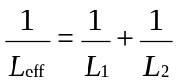
For the parallel connection, E₁ = E₂ = E and I = I₁ + I₂ and dI/dt = dI₁/dt + dI₂/dt. The emfs are E = L₁ dI₁/dt and E = L₂ dI₂/dt. Define L_{eff} by L_{eff} = E/(dI/dt). Then L_{eff} = E/(E/L₁ + E/L₂) = L₁L₂/(L₁ + L₂) or 1/L_{eff} = 1/L₁ + 1/L₂.

93* ·· A long solenoid has n turns per unit length and carries a current given by I = I₀ sin wt. The solenoid has a circular cross section of radius R. Find the induced electric field at a radius r from the axis of the solenoid for
(a) r < R and (b) r > R.
(a) The field within the solenoid is B = μ₀nI. The flux through an area πr² for r < R is then φ_{m} = πr²μ₀nI. We now apply Equ. 30-5 and obtain 2πrE = –dφ_{m} /dt. Solving for E we find E = –(μ₀nrI₀ω /2) cos ωt.
(b) Proceed as in part (a) with φ_{m} = πR²μ₀nI. One obtains E = –(μ₀nR²I₀ω /2r) cos ωt.

94 ··· A thin-walled hollow wire of radius a lies with its axis along the z axis and carries current I in the positive z direction. A second identical wire is parallel to the first with its axis along the line x = d. The second wire carries current I in the negative z direction. (a) Find the magnetic flux per unit length through the space in the xz plane between the wires. (b) If the far ends of the wires are connected together so that the parallel wires form two sides of a loop, find the self-inductance per unit length of the loop.
(a) Since the two wires carry the same current but in opposite directions, the fields produced by them in the region between the wires are in the same direction. Moreover, the total flux in this region is just twice the flux due to the current in one of the wires. We can now use the result of Problem 30-10, with b = 1 m, d replaced by a, and a replaced by d – 2a. Thus the flux per unit length due to the currents in the two wires in the specified region is φ_{m} = (μ_{o}I/π) ln[(d – a)/a].
(b) From the definition of L, Equ. 30-7, L = (μ₀/π) ln[(d – a)/a]

95 ··· A coaxial cable consists of two very thin-walled conducting cylinders of radii r₁ and r₂ (Figure 30-50). Current I goes in one direction down the inner cylinder and in the opposite direction in the outer cylinder. (a) Use Ampère's law to find B. Show that B = 0 except in the region between the conductors. (b) Show that the magnetic energy density in the region between the cylinders is
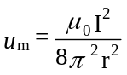
(c) Find the magnetic energy in a cylindrical shell volume element of length and volume dV = 2πr dr, and integrate your result to show that the total magnetic energy in the volume of length is
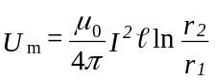
(d) Use the result in part (c) and U_{m} = 0LI ² to show that the self-inductance per unit length is
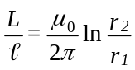
(a) The system exhibits cylindrical symmetry, so one can use Ampère’s law to determine B. For r < r₁ and for r > r₂ the net enclosed current is zero; consequently, in these regions B = 0. For r₁ < r < r₂, 2πrB = μ₀I and B = μ₀I/2πr.
(b) u_{m} is given by Equ. 30-17; i.e., u_{m} = μ₀I ²/8π²r² in the region between the two cylinders.
(c) U_{m} = ∫u_{m} dV, where dV = 2πrdr. Integrating from r = r₁ to r = r₂ one obtains U_{m} = (μ₀I ²/4π) ln(r₂/r₁).
(d) Set = 1 m and use the relation U_{m} = 1/2LI ². Then L = (μ₀/2π) ln(r₂/r₁) per unit length.

96 ··· In Figure 30-50, compute the flux through a rectangular area of sides and r₂ – r₁ between the conductors. Show that the self-inductance per unit length can be found from φ_{m} = LI (see part (d) of Problem 95).
Consider a strip of unit length and width dr at a distance r from the axis. The flux through this area is given by
dφ_{m} = B dA = B dr = (μ₀I/2π) dr/r. Integrating from r = r₁ to r = r₂ one obtains φ_{m} = (μ₀I/2π) ln(r₂/r₁). Using the definition for L, Equ. 30-7, L = (μ₀/2π) ln(r₂/r₁).

97* ··· Figure 30-51 shows a rectangular loop of wire, 0.30 m wide and 1.50 m long, in the vertical plane and perpendicular to a uniform magnetic field B = 0.40 T, directed inward as shown. The portion of the loop not in the magnetic field is 0.10 m long. The resistance of the loop is 0.20 Ω and its mass is 0.50 kg. The loop is released from rest at t = 0. (a) What is the magnitude and direction of the induced current when the loop has a downward velocity v? (b) What is the force that acts on the loop as a result of this current? (c) What is the net force acting on the loop? (d) Write the equation of motion of the loop. (e) Obtain an expression for the velocity of the loop as a function of time. (f) Integrate the expression obtained in part (e) to find the displacement y as a function of time. (g) From the result obtained in part (f) find t for y = 1.40 m, i.e., the time when the loop leaves the region of magnetic field. (h) Find the velocity of the loop at that instant. (i) What would be the velocity of the loop after it has dropped 1.40 m if B = 0?
(a) E = Bv; I = E/R; use Lenz’s law  (b) F_{v} = BIdirected up  (c) F_{net} = mg – F_{v}  (d) F_{net} = ma = m(dv/dt)  (e) See Problem 5-88  (f) y(t) = ∫v(t) dt  (g) Find t for y = 1.40 m by trial and error  (h) Find v(0.538 s) from part (e)  (i) 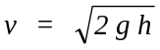 | I = (0.4×0.3/0.2)v A = 0.6v A, clockwise  F_{v} = (0.4×0.3×0.6)v A = 0.072v N, directed up  F_{net} = (0.5g – 0.072v) N, directed down  0.5g – 0.072v = 0.5(dv/dt)  v(t) = 68.1(1 – e^{–0.144t}) m/s  y(t) = 68.1[t + 6.94(e^{–0.144t} – 1)] m  t = 0.538 s  v(0.538 s) = 5.08 m/s  v = 5.24 m/s

98 ··· The loop of Problem 97 is attached to a plastic spring of spring constant κ (Figure 30-52). (a) When B = 0, the period of small-amplitude vertical oscillations of the mass–spring system is 0.8 s. Find the spring constant κ. (b) When B ≠ 0, a current is induced in the loop as a result of its up and down motion. Obtain an expression for the induced current as a function of time when B = 0.40 T. (c) Show that the induced current acts as a damping mechanism. (d) Determine the value of the magnetic field for which the Q of the mass–spring system is 100.
(a) Use Equ. 14-12; κ = 4π²m/T ²  - Let y = y₀ sin ωt; find E/R; E = Bv  (c) The damping force is of the form F_{d} = –bv  (d) 1. Find the energy loss per cycle  2. Write the energy of the oscillator  3. Q = 2πE/ΔE; solve for B | κ = 30.8 N/m  E/R = [(0.4×0.3×7.85y₀ /0.2) cos 7.85t] A  I = (4.71y₀ sin 7.85t) A  F_{d} = –BI= –(0.565y₀ cos 7.85t) N  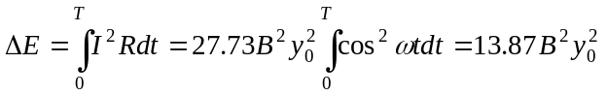  E = 1/2κy₀² = 15.4y₀²  B² = (15.4×2π/1387) T²; B = 0.264 T

99*··· Show that the effective inductance of two inductors, L₁ and L₂, connected in series and in close proximity, is
L_{eff} = L₁ + L₂ ± 2M. When should the plus sign be used in this expression, and when should the minus sign be used?
We need to find L in terms of L₁, L₂, and M. We recall that the flux in the coil L₁ is φ_{m1} ± I₂M and the flux in the coil L₂ is φ_{m2} ± I₁M, where we have used φ_{mi} to denote the flux due to each inductor when isolated from the other. Since the same current flows through both inductors, the total flux linking the two inductors is
φ_{m} = L₁I + L₂I ± 2MI, and consequently L_{eff} = L₁ + L₂ ± 2M. The positive sign should be used if the two inductors are wound in the same sense so that the fluxes add, the negative sign if the inductors are wound in an opposing sense so that the fluxes subtract.

